Practice Test for Chapter #1 and Chapter #2

1 Which subatomic particle contributes mass but no charge to the atom?
A Proton
B Neutron
C Electron
D Nucleon
2 The atomic number of zinc is:
A 65.
B 30.
C 91.
D 40.
For questions 3–5 refer to the table below, which shows the electron configuration of six atoms, labelled I–VI.
Atom | I | II | III | IV | V | VI
Electron configuration | 2, 1 | 2, 8, 7 | 2, 8, 8, 2 | 2, 8 | 2, 3 | 2, 8, 1
3 Which atom/s are from the same period of the periodic table?
A I, II, III
B I and IV
C II, III, VI
D I, IV, V
4 Which atom is an inert gas?
A I
B II
C III
D IV
5 Which atom has five protons?
A I
B III
C V
D VI

6 The diagram below shows an atom of beryllium. What is the name of the structure labelled X?
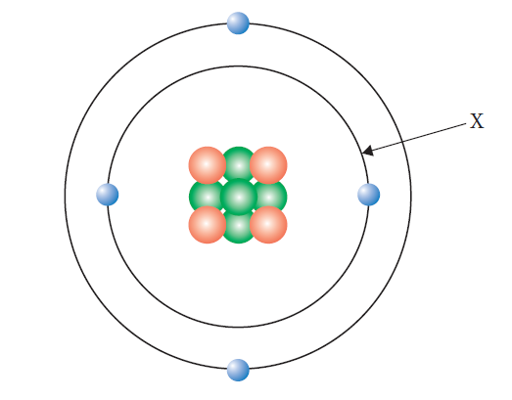
A Valence electron
B Nucleus
C Electron shell
D Electron
7 Why is the relative atomic mass on the periodic table a decimal?
A It is the average of the abundance and mass of all of the isotopes of the element.
B It is the average of the abundance and mass of all of the allotropes of the element.
C It depends on the percentage abundance of the element in the Earth’s crust.
D It depends on which atom of carbon the element is being compared to.
8 The order of subshells in terms of their energy is:
A 1s<2s<3s<4s<2p<3p<4p.
B 1s<2s<2p<3s<3p<3d<4s<4p.
C 1s<2s<2p<3s<3p<4s<3d<4p.
D 1s<2s<3s<3p<4s<4p.
9 Which of the elements below has the largest atomic radius?
A Potassium
B Calcium
C Bromine
D Krypton

10 Which of these elements has the lowest ionisation energy?
A Fluorine
B Chlorine
C Bromine
D Iodine
11 Which of the following elements react with water in similar ways?
A Na and Al
B Na and K
C Mg and P
D Li and Br
12 If two electrons were removed from a neutral atom with the electron configuration 2, 8, 2 the new species would then have the same number of protons as:
A Ne.
B Mg.
C F.
D Na.
13 Which of the following is a semi-metal?
A Be
B B
C P
D Mg

14 Which of the following describes why water droplets appear on a cold bathroom mirror when you are having a hot shower?
A Evaporating
B Boiling
C Melting
D Condensing
15 In which of the following separation techniques is the term residue used?
A Evaporation
B Decanting
C Sieving
D Filtration

16 Immiscible liquids are generally separated in the science laboratory using:
A a filter funnel.
B a separating funnel.
C a condenser.
D a Bunsen burner and evaporating basin.
17 What does the term filtrate refer to?
A Smaller solid particles that pass through a sieve
B Solid particles that are too large to pass through filter paper
C The liquid or solution that passes through the filter paper
D The liquid or solution that remains after evaporating
18 Evaporation is used as a separation technique when:
A only the solute is to be kept.
B only the solvent is to be kept.
C solid particles can be seen in the mixture.
D both the solute and the solvent are to be kept.
19 Which of the following is not a mixture?
A Tap water
B Carbon dioxide gas
C Coffee
D Air
20 When a liquid is cooled enough, it will turn into a solid. The temperature at which this occurs is known as the:
A boiling point.
B melting point.
C state.
D thermal conductivity.
21 Mixtures that contain solids with different particle sizes are not usually separated by:
A sieving.
B vaporisation.
C filtration.
D straining.

22 During distillation, the thermometer is used to:
A work out when the substance with the highest boiling point has changed into a gas.
B control the temperature of the liquid or solution being heated in the round-bottom flask.
C determine the temperature of the vapour entering the condenser.
D ensure the experiment remains safe at all times when carried out in the laboratory.
23 Which of the following is always a mixture?
A An element
B A compound
C A liquid
D A solution

24 Which of the following is false?
A Mixtures can be solids, liquids or gases.
B Mixtures can be homogeneous or heterogeneous.
C Mixtures contain at least two different types of particle physically combined.
D Mixtures always have variable composition.

Section B Short answer
1 Oxygen has three isotopes, oxygen-16, oxygen-17 and oxygen-18. Their relative abundances are 99.76%, 0.04% and 0.20% respectively.
a Define the term isotope. (1 mark)

b Calculate the relative atomic mass of oxygen. (2 marks)

2 Complete the following table.
Element | Atomic number | Mass number | Number of protons | Number of neutrons | Number of electrons
beryllium | 4 | 9
selenium |  |  |  | 45 | 34
(3 marks)
3 Explain why ionisation energy and atomic radius show opposite trends for the first 20 elements. (3 marks)

4 The properties of three elements, X, Y and Z, are shown below.
Element/property | Boiling point | Melting point | Electrical conductivity (solid)
X | –152 | –157 | n/a
Y | 609 | 419 | high
Z | 892 | 98 | high
a Compare the state at room temperature for elements X and Y. (2 marks)

b Describe where element Z would be found on the periodic table. Give a reason for your answer. (1 mark)

5 Complete the following table.
Separation method | Property used in the separation (with both components to be retained)
 | The components are liquids with different densities
Filtration
 | The components are substances with different boiling points
(3 marks)
6 A student was given a mixture of sodium chloride (common table salt), small cork pieces, dirt and iron filings. Draw a flow chart to show the procedure the student should follow, if all components are required to be kept. Be sure to show what is removed at each step. (3 marks)

7 The table below compares some properties of two substances, I and II. Decide whether each substance is an element, compound or mixture. Give reasons for your answers. (3 marks)
Substance | Melting point | Separation/decomposition
I | No definite melting point | Components can be separated by physical means
II | > 900°C | Cannot be decomposed into simpler substances

8 Draw particle diagrams of specific examples of substances to illustrate the difference between a pure substance and a mixture. (3 marks)

9 Using correct scientific terminology, clearly explain how the process of distillation can be used to separate a mixture of water and ethanol (BP = 78°C). (3 marks)

Answers are available on the Connect website (http://connect.det.wa.edu.au)

Remember, 20% of the test will be on content from Test #1, including:
- writing formulas and names of compounds
- calculations
  - particles, moles and mass calculations
  - empirical formula
  - percentage mass
  - mass to mass calculations using balanced equations

These topics were not included on this practice test, so you will need to do your own revision for these topics.

